NGO SUSTAINABILITY
GLOBAL WARNING +1.2°C
LATEST NEWS IN SUSTAINABILITY
NO. 144 | October 2023

PROMOTING SUSTAINABLE LIVING AND RENEWABLE ENERGY FOR THE FUTURE OF OUR PLANET
ngosustainability@gmail.com | unngosustainability.org

Consultative Status, the United Nations Economic and Social Council (ECOSOC)
Observer Status, United Nations Environment Programme (UNEP)

Your comments are always welcome.
Please feel free to reproduce and share with your colleagues.
- NGO Sustainability team

“The SDGs aren't just a list of goals. They carry the hopes, dreams, rights, and expectations of people everywhere." -Antonio Guterres, UN Secretary General

Jane Fonda
Jane Fonda, the American actress, has played a significant role not only in the realm of entertainment but also as a dedicated political activist.¹ Her involvement in political activism commenced in the 1970s, marked by her outspoken stance against the Vietnam War.¹ In recent years, Jane Fonda has shifted her
focus towards raising awareness about the pressing issue of climate change, engaging in acts of civil disobedience and protest.² Notably she has partnered with Greenpeace to hold "Fire Drill Fridays" protests in Washington D.C., aiming to rally support for the Green New Deal and protest the US government's failure to adequately address climate change.

Jane Fonda at Fire Drill Friday March on Capitol Hill, protesting financial institutions accountable for financing the fossil fuel industry. January 2020. Photo: Getty Images
Fonda has recently launched her own political action committee - the Jane Fonda Climate PAC,dedicated to raising awareness about climate change. ³

“Letters to Walt Whitman”

by Ronald Johnson

I hear you whispering there O stars of heaven,
O suns - O grass of graves...
If you do not say anything how can I say anything?

Let us tunnel

the air
(as a mole's green galleries)
toward the ultimate

cornfield
- the square of gold, & green, & of tassel

that rustles back at us -

let us burrow in
to a susurration, the dense starlings,

of the real -
the huge
sunflowers waving back at us,

- the great grassy world

that surrounds us,
singing.

“UK and Germany Sign Hydrogen Partnership to Boost Net Zero Efforts”
By: ESG News
Photo: Getty Images
The United Kingdom and Germany have formed a new collaborative partnership focused on
advancing hydrogen technology, pledging joint investment of over €110 million towards
decarbonization efforts. The countries aim to boost production and infrastructure for "green"
hydrogen derived from renewable energy sources as a sustainable fuel option for transportation, heating, industry and more. Specifically, they plan to back 40 hydrogen research projects with €60 million in funding and support development of hydrogen refueling stations and supply chains with €50 million. Beyond investment, the partnership will involve sharing technical knowledge and coordinating on regulatory standards to enable international hydrogen trading. The partnership sends a statement that major world economies are committed to collaborating on clean energy innovation to create jobs and accelerate emissions reductions.
Full Article

“Danish Pension Fund AkademikerPension Wraps Up $520 Million Divestment in Fossil
Fuel Stocks” ESG News
Photo: Getty Images

The Danish pension fund AkademikerPension has now fully completed its fossil fuel divestment plan, selling off €520 million in stocks and bonds from 10 major oil, gas, and coal companies over the past year. This landmark divestment, one of the largest moves by a European pension fund to date, is a key part of Akademiker Pension's broader strategy to invest sustainably and proactively address climate change. Specifically, the fund aims to transition its €30 billion portfolio to net zero greenhouse gas emissions by 2050. To that end, AkademikerPension has redirected the €520 million into other assets including renewable energy companies, green bonds, and climate-friendly real estate. With bold steps like this large-scale divestment, AkademikerPension hopes to send a strong signal that pension funds can and should align investment decisions with climate priorities and societal wellbeing.

Full Article

“How can a circular economy help shift the Plastics Industry agenda?”
By: Vilislava Ivanova, The EY Sustainability Matters Podcast
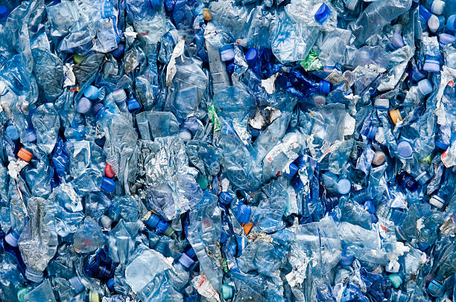
Photo: Getty Images

Certain companies, including Eastman Chemical Company, are looking to create more sustainable practices with a “circular” solution to handling waste produced by plastics. This company helps to promote more sustainable practices by working with companies including plastic manufacturers and recyclers. For example, informing companies of practices including the molecular recycling of plastics allows for a more diverse range of plastics to be recycled, addressing the primary issue of actually recycling plastic at the end of its life cycle. The partnerships formed by Eastman with companies in other countries, such as France, has revealed that plastics recycling may be able to take place with more sustainable techniques that reduce greenhouse gas emissions, including the use of renewable energy sources to power the electric grid itself.

Full Article
“A saltwater wedge climbing the Mississippi River threatens drinking water”
By: Brandy Dennis, Washington Post
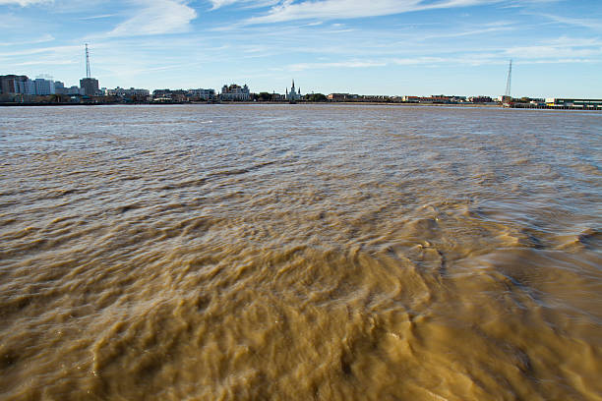
Photo: Getty Images
New Orleans vegetation that requires freshwater is being threatened by rising levels of saltwater from the Gulf of Mexico making its way into the Mississippi River. Flooding of saltwater from the Gulf has become a larger problem within recent years due to the weakening flow of the Mississippi River, which could threaten plant populations that cannot tolerate salt water, and freshwater drinking supplies in parts of Louisiana. Declarations of emergency from the New Orleans Mayor Latoya Cantrell have promoted efforts to construct an underwater barrier, called a sill, to stop saltwater from progressing further up the river. However, further reinforcements may need to be made in the future as well, as long periods of droughts that are reducing the flow of the Mississippi River against the Gulf of Mexico are worsening, highlighting one difficulty relating to climate change in many coastal regions.

Full Article
“Canada, a giant oil producer, urges others to end fossil fuel subsidies”
By: Timothy Puko, Washington Post
Photo: Getty Images

In light of record high subsidies in countries including the U.S. promoting investments in fossil fuels, Canada has urged the U.S. and other countries to stop subsidizing fossil fuels. However, recent economic downturns due to a lack of Russian oil exports during its war with Ukraine has made countries hesitant to stop subsidizing domestic or foreign oil exploration and extraction elsewhere. Indeed, many Congress Republicans in the United States have made promises to citizens to heavily boost production of oil to lower gas prices, proving that fossil fuel production may fail to gain political traction, even in countries that expressed desire from previous climate talks to reduce greenhouse gas emissions. Overall, these calls to action by Canada may not prove to be effective alone in promoting other countries to reduce their greenhouse gas emissions, showing lasting difficulties to transition to a more sustainable global economy that phases out all fossil fuels.
Full Article
“ICRI, network of 45 Countries pledge to raise $12 billion to Fund Coral Reef Protection”
By: ESG News
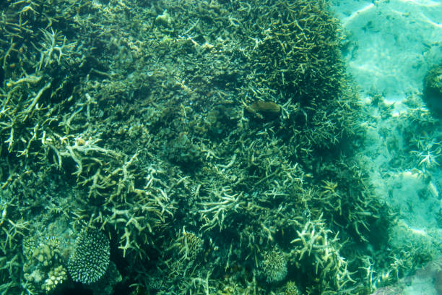
Photo: Getty Images
The International Coral Reef Initiative (ICRI), a partnership of over 45 countries and
organizations, has pledged to raise and deploy USD $12 billion in funding by 2030 specifically
towards global coral reef conservation efforts. This represents the largest financial commitment ever made towards protecting these unique ocean ecosystems.. ICRI members outlined an extensive plan to use the pledged funds to scale up restoration and adaptation projects, strengthen marine protected areas, improve water quality, tackle invasive species, and expand coral farming. Major donors at the recent ICRI General Meeting included the Bezos Earth Fund committing $74 million, the Bloomberg Foundation granting $10 million, and the government of Australia earmarking $1 billion towards the Great Barrier Reef. Experts estimate restoring just 1% of degraded reefs per year globally could require $5 billion annually. By mobilizing major new public, private and philanthropic resources, ICRI aims to spur the transformative action needed to reverse the projected 70-90% loss by mid-century.
Full Article
“White House defines ‘zero-emission’ buildings, hoping more get built”
By: Maxine Joselow, Washington Post
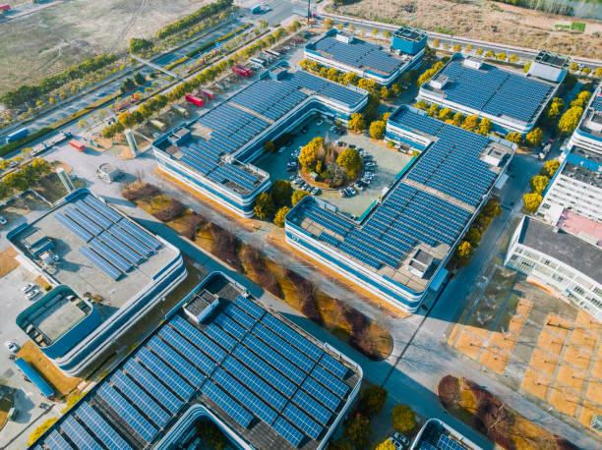
Photo: Getty Images

There is a recently developed new standard for ‘zero-emission buildings’ set by the Biden administration to prevent infrastructure energy requirements from further contributing to climate change. This exact definition, including requirements for state and local governments to follow in developing buildings, will be announced soon in the Greenbuild International Conference and Expo. Classifications of these buildings will likely require them not to produce emissions from the buildings themselves, and eventually completely transition to renewable energy. Many restrictions remain that prevent policies on creating ‘zero-emission buildings’ from becoming universal, including not imposing carbon reduction standards for private housing, but this represents a promising effort in cutting emissions from infrastructure, an area that is among the highest in emissions.

Full article
“Arctic Lakes Are Carbon Banks. What Happens When They Heat Up”
By: Cheryl Katz, Mother Jones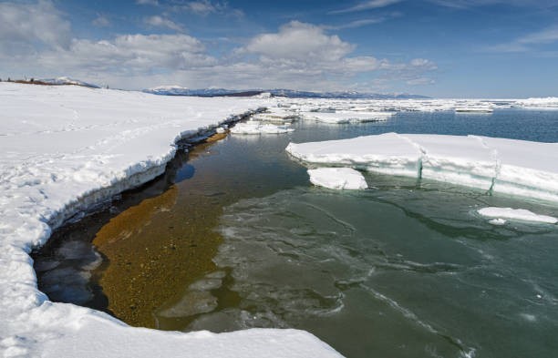
Photo: Getty Images
Researchers traveling to some of the traditionally coldest countries inhabited by humans within the Arctic are finding more formerly frozen lakes that are almost entirely melted. Many lakes across arctic regions are melting weeks earlier in the year and freezing much later, which has come due to rising global temperatures. These obvious indicators of global warming are cause enough for concern, but the release of carbon stored within organisms like plankton, which use carbon dioxide for their own biological function, is another alarming threat associated with the melting of these lakes. This could make the Arctic in general, a region which traditionally stores more carbon than it releases, a net releaser of carbon from lakes, as well as carbon buried in Arctic soils. In response to these concerns, scientists from various universities and other organizations in the regions are beginning to test and record levels of carbon dioxide emissions and tracking the melting of lakes and frozen soil.
Full Article
The European Union and Climate Change
Goals and Achievements
Special Report by Intern: Elianne Kjellman

The European Union is one of the world’s leading organizations of governments confronting climate change. Under European climate law, all member states must cut their greenhouse gas emissions by 55% before 2030 (compared to 2020 levels), with the ultimate goal of the EU being a climate neutral bloc by 2050. The goals are part of the European Green Deal – an initiative to transform the continent’s climate politics led by the President of the European Commission, Ursula von der Leyen. Among other things, the Green Deal hopes to improve the well-being of European citizens by providing clean water, energy efficient buildings, healthy and affordable food, and accessible public transport. One major focus area is clean innovation and technology, as von der Leyen restated in her State of the Union address on September 13 2023, saying: “The future of our clean tech industry has to be made in Europe.”
EU climate goals are aligned with the 2015 Paris Agreement and its main objective of keeping global warming below 2 degrees Celsius. The substantial goals require major public and private financial investments. In light of this, EU member states have agreed that 30% of total EU expenditure will go to climate-related projects until 2027. This commitment means the European Union is currently the largest provider of climate financing in the world. One notable and highly publicized initiative that has followed the Green Deal is the union’s plans to cut emissions from transport. In 2022, the European Parliament and Council reached an agreement stating that all new cars and vans registered in Europe must produce zero CO2 emissions by 2035. Frans Timmermans, Executive Vice-President of the European Green Deal, said of the decision: “The agreement sends a strong signal to industry and consumers: Europe is embracing the shift to zero-emission mobility. European carmakers are already proving they are ready to step up to the plate, with increasing and increasingly affordable electric cars coming to the market. The speed at which this change has happened over the past few years is remarkable.” In March of 2023, EU member states gave their final approval to turn the goal into EU law.
Past and present work
The European Union includes climate policy in its different levels of action. Internally, policies in different sectors include a climate perspective to increase the continent’s resilience. The union supports member states’ national work on resilience, as well as that of partners in the private sector. Globally, the union supports international conventions and agreements, and works to expand international financing and engagement towards climate adaptation. The New European Bauhaus, for example, is an initiative that intends to connect the Green Deal with European living spaces by focusing on architecture and city planning. Following the key words of enriching, sustainable, and inclusive, the initiative works as a platform for experimentation and connection, and grants EU funding for projects that fit the union’s climate goals.
The union has made several achievements, including a reduction in the share of the world’s greenhouse gas emissions from 15.2% in 1990 to 7.3% in 2019. In order to meet the previously mentioned 2030 targets, member states are required to create a National Energy and Climate Plan (NECP) which outlines how they intend to address five dimensions: decarbonization, energy efficiency, energy security, internal energy market, as well as research, innovation and competitiveness. Each member state is furthermore required to submit a progress report on the status of their NECP every other year. However, only 15 out of 27 member states successfully submitted their updated reports by the most recent deadline in June of 2023. Among the ones who failed to submit were Germany and France, the biggest greenhouse gas polluters in Europe.
In response to the 2022 Russian invasion of Ukraine and the threat to European energy security that followed, the European Union the same year introduced its RePowerEU plan. The main goals of the plan were to save energy, produce clean energy, and diversify energy supplies. Achievements of the RePowerEU plan include a reduced dependency on Russian fossil fuels. Russian gas only accounted for 8% of gas imports to the EU in September of 2022 compared to 41% in August of 2021. The plan also yielded 20% savings in energy consumption, introduced a cap to gas prices and doubled the additional deployment of renewables. Following the introduction of RePowerEU, the union is for the first time generating more electricity from solar and wind than it is from gas. A record 41 GW of new solar energy capacity was installed in 2022, and wind capacity was increased by 16 GW. The result is a record 39% of European energy deriving from renewable sources. According to the RePowerEU webpage: “Putin’s attempt to blackmail Europe using energy has failed.”
Criticism
However, the European Union is and has been a great contributor to environmental degradation. In 2019, the EU was the fourth biggest greenhouse gas emitter after China, the US, and India (when counting the EU as one entity and not considering member states’ emissions separately). At the time of writing, only 15% of the natural habitats within the union’s borders are considered to be in good condition. 38% of fish populations are in bad condition and the continent’s main pollinators of bees and butterflies are considered to be in very poor condition. The World Wildlife Fund asserts that the EU’s 55% net emissions reduction target by 2030 is far from enough, and campaigns for stronger European measures to be taken. The independent scientific project Climate Action Tracker (CAT) rates the union’s climate work as ‘insufficient’ when measuring government action against the Paris Agreement’s goal of keeping global warming below 2 degrees Celsius. CAT maintains that the policies introduced by the EU following the Russian invasion of Ukraine would be incredibly environmentally rewarding if followed. However, continued European investments in fossil fuels cast a shadow on the prospects of these ambitious policies.

Mitrex Solar
Company Report by Intern: Colin Costigan

Toronto based Mitrex - Integrated Solar Technology is at the forefront of a visionary approach, aiming to transform every sun-exposed surface into a source of electricity. Through their innovative building-integrated photovoltaic (BIPV) systems, Mitrex enables the generation of electricity from various building components such as windows, railings, sidings, and facades. Notably, Mitrex's products possess the unique advantage of offering customizable cladding options, allowing for seamless integration of solar panels into diverse architectural designs. This report provides an overview of Mitrex's integrated solar technology, its development, and future prospects.

Building-integrated photovoltaic (BIPV) systems represent a revolutionary approach to solar energy utilization by seamlessly integrating solar panels into various architectural elements. Instead of being standalone structures, BIPV systems merge solar power generation with building design, providing dual benefits of energy production and aesthetic enhancement. Mitrex's BIPV systems incorporate solar panels into the design of building components, enabling the generation of electricity while maintaining aesthetic appeal.
Mitrex's Research and Development (R&D) team was established in 2015 with the primary objective of integrating solar technology into cladding systems. In 2019, Mitrex secured a

substantial investment of $100 million to establish a state-of-the-art manufacturing facility in Rochester, NY dedicated to custom production. This strategic investment allowed the company to embark on its inaugural solar integrated project, which was successfully launched in 2021. Notably, Mitrex's R&D team has made significant progress in the past year, developing pioneering solar brick and glass solutions, as showcased in the accompanying pictures. These advancements demonstrate the company's commitment to innovation and continuous improvement, and to “push the boundary” of integrated solar technology.

Mitrex's journey towards widespread implementation of building-integrated photovoltaic systems remains promising. The company envisions a future where solar technology is seamlessly integrated into all aspects of the built environment. This vision is aligned with the growing global demand for sustainable energy solutions and the increasing focus on reducing carbon footprints in the construction industry. By continuously innovating and improving its technology, Mitrex aims to revolutionize the way buildings generate electricity, contributing to a more sustainable and energy-efficient future.

Diet for a Small Planet
By Frances Moore Lappé
Book Report by Intern: Johanna Tartaglia

Frances Moore Lappé's "Diet for a Small Planet" addresses the pressing issues of world hunger, resource scarcity, and environmental sustainability. The book begins by examining the inefficient use of resources in the prevailing meat-centered diet of Western societies. Lappé argues that the production of meat requires significant amounts of land, water, and grain, which could be utilized more efficiently to directly feed humans. She highlights the detrimental environmental impact of animal agriculture, including deforestation, water pollution, and greenhouse gas emissions.

Lappé introduces the concept of protein complementarity as a solution to the misconception that meat is the sole source of complete protein. She explains that by combining different plant-based proteins, such as grains and legumes, individuals can obtain all the essential amino acids required by the human body. This challenges the belief that meat is necessary for a nutritionally balanced diet and promotes the idea that plant-based foods can provide adequate protein.

The book emphasizes the importance of shifting towards a more plant-based diet to address world hunger. Lappé argues that by reducing the consumption of meat and embracing plant-based alternatives, we can utilize resources more efficiently and feed a larger population. She provides practical suggestions and recipes for protein
combining to ensure a nutritionally balanced vegetarian or vegan diet.

In addition to discussing the environmental implications of food choices, Lappé also delves into the socio-economic factors contributing to global hunger. She highlights the unequal distribution of food and resources, pointing out that hunger is not solely a result of scarcity but rather a consequence of social and economic inequalities. She advocates for a fairer food distribution system that ensures everyone has access to nutritious food.

Throughout the book, Lappé encourages individuals to recognize the power of their consumer choices and the potential for political action. She believes that by making conscious decisions about what we eat and supporting policies that promote sustainable agriculture, individuals can contribute to positive change in the food system. She emphasizes the need for collective action, urging readers to engage in grassroots movements, advocate for policy reform, and challenge the dominant narrative surrounding food production and consumption.

"Diet for a Small Planet" presents a comprehensive analysis of the interconnected issues of food, sustainability, and social justice. The author calls for a shift towards plant-based diets, highlights the environmental consequences of meat production, and emphasizes the importance of equitable food distribution. The book has had a significant impact on promoting vegetarianism, raising awareness about the environmental impacts of food choices, and inspiring individuals to take action towards a more sustainable and equitable future.

Producer: Roma Stibravy, President
Editor: Catie Eiref - Columbia University Mailman School of Public Health
Contributors: NGO Sustainability Interns
BECOME A MEMBER OF NGO SUSTAINABILITY!
SEE CORPORATE SPONSORSHIP OPPORTUNITIES
unngosustainability.org

Johnson Ronald, “Letters to Walt Whitman” poetryfoundation.org. Accessed October 12, 2023, https://www.poetryfoundation.org/poetrymagazine/poems/30329/letters-to-walt-whitman

