
NGO SUSTAINABILITY
GLOBAL WARNING 1.2°C
LATEST NEWS IN SUSTAINABILITY
NO. 155 | September 2024
PROMOTING SUSTAINABLE LIVING AND RENEWABLE ENERGY FOR THE FUTURE OF OUR PLANET
ngosustainability@gmail.com | unngosustainability.org

Consultative Status, the United Nations Economic and Social Council (ECOSOC)
Observer Status, United Nations Environment Programme (UNEP)

Don’t hesitate to provide feedback here. Your comments are always welcome.
Please feel free to reproduce and share.
- NGO Sustainability Team
“Earth provides enough to satisfy every man’s needs, but not every man’s greed.”
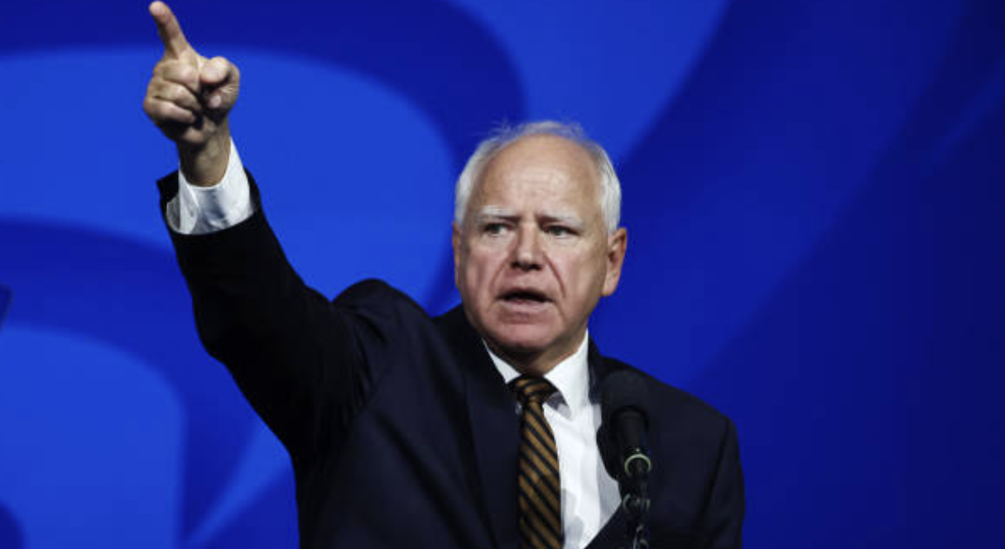
–Mahatma Gandhi
Tim Walz

Tim Walz is the current Governor of Minnesota, a former congressman, and Vice President Kamala Harris’s running mate for the 2024 presidential election.

Walz has long been an environmentalist while in public office. In the U.S. House, he had a 75% pro-environment voting record. As governor, he has signed numerous climate-related pieces of legislation into law, including mandating 100% carbon-free electricity by 2040 and banning PFAS “forever chemicals”. In 2022, Governor Walz introduced Minnesota’s Climate Action Framework, a comprehensive 69-page plan outlining six key goals for combating climate change. The plan targets increasing electric vehicle adoption to 20% by 2030 and achieving net-zero carbon emissions by 2050.

Harris’s selection of Walz as her running mate solidifies climate change as an issue that is a centerpiece of her campaign. This is evidenced by Kamala having received endorsements from environmental groups such as the League of Conservation Voters and Sierra Club.

Governor of Minnesota, Tim Walz
Source: Getty Images

As Climate Week unfolds, Governor Walz emphasizes Minnesota's commitment to the environment, stating, “Minnesota is leading the way in climate solutions. We have reduced greenhouse gas emissions, improved energy efficiency, and invested in climate resilience”.

Source:
League of Conservation Voters. (n.d.). Tim Walz. Scorecard. https://scorecard.lcv.org/moc/tim-walz
Minnesota Governor’s Office. (2023, May 18). Governor Walz signs historic environment and climate bill into law. https://mn.gov/governor/newsroom/press-releases/#/detail/appId/1/id/646146
MPR News. (2023, May 18). State lawmakers agree to historic environment and climate bill. https://www.mprnews.org/story/2023/05/18/state-lawmakers-agree-to-historic-environment-and-climate-bill
Fast Company. (2023, May 18). What has Tim Walz done for the climate as Minnesota governor? https://www.fastcompany.com/91168366/what-has-tim-walz-done-for-the-climate-as-minnesota-governor
Instagram. (2021, April 20). [Post by Tim Walz]. https://www.instagram.com/p/C-VKQ0PuGKB/
Sierra Club. (2024, July 10). Leading environmental and climate organizations endorse vice president. https://www.sierraclub.org/press-releases/2024/07/leading-environmental-and-climate-organizations-endorse-vice-president
Minnesota Governor’s Office. (n.d.). About Governor Tim Walz. https://mn.gov/governor/about-gov/timwalz

Burning Earth
By Jordan Sanchez

What if the ocean caught on fire?

Suddenly burst into flames.

Not like one on the stove,

or a candle on the dinner table,

but something that resembles the end of the world.

The flames swallowing the Earth and licking the sky

and you’re just standing there

at the edge of the beach

with your toes in the sand,

and now every grain feels like glass

that’s cutting into the soles of your feet

that feel like they’re burning too.

The tears you shed turn to steam

that disappears before your eyes

that watch the world disappear with you in it.

Suddenly there is no sun,

there is no moon,

or maybe they’re there

or the fire got them too.

But the world is burning,

crying out to you in the form of ashes and smoke,

and you sit there: hopeless.

On April 28, 2010,

the Gulf of Mexico is set on fire.

The ocean is bronze and black

like there’s a dragon hiding

beneath the surface.

The triumphant smoke rises from the flames

and fills the sky.

It shields the sun, and, for a second,

the birds are unsure if this is Earth anymore.

They have known no other world-

we have known no other world.

This feels like a nightmare,

and all you can do is wait for it to be over,

but there is no sign as to when that will be.
“Climate change costs Africa up to 5% of GDP, UN climate head says”
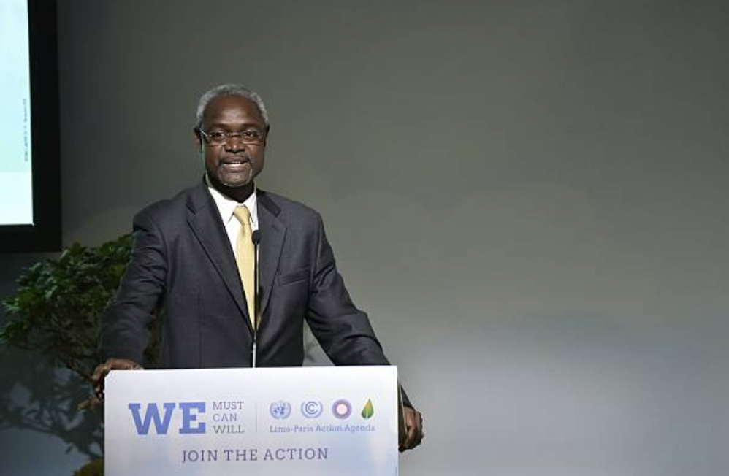
By: Duncan Miriri, Reuters
Photo: Getty Images
On September 5th, the head of the IPCC, Simon Stiell issued a warning to the continent of Africa. According to him, "The climate crisis is an economic sinkhole, sucking the momentum out of economic growth," and warned that as much as 5% of the GDP of the African countries is being lost to the impacts of climate change. The continent gets a mere fraction of the $100 billion in global financing distributed worldwide for climate mitigation and adaptation practices, which is a far cry from the $1.3 trillion which officials say is necessary to adequately address the crisis at hand. At the conference of parties of the United Nations Framework Convention on Climate Change (UNFCCC) in November of this year, at Baku, Azerbaijan, there are increasing efforts to secure more financing for Africa.

Full Article

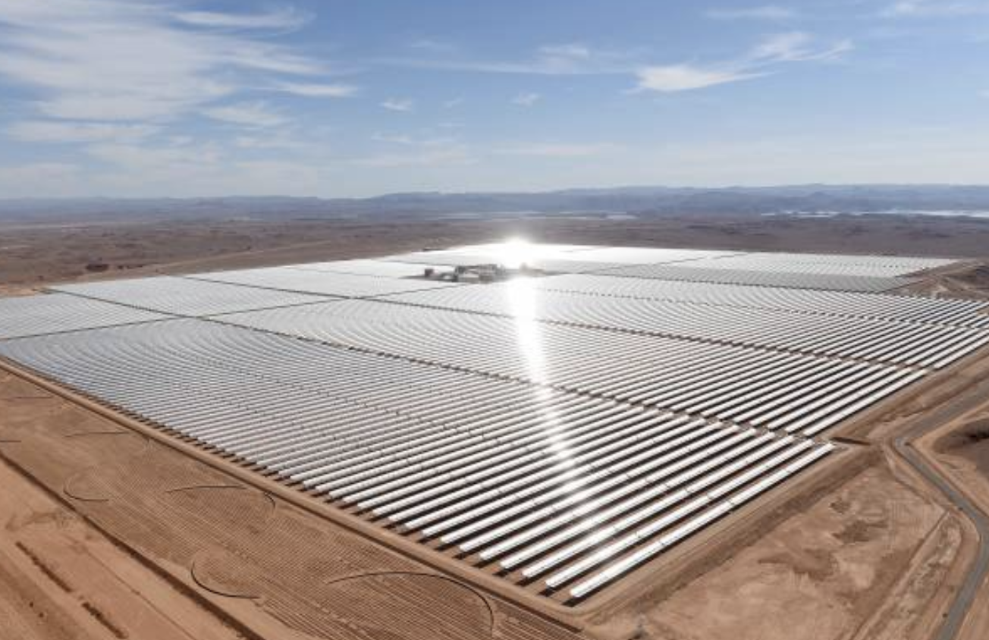
“Guinea Turns to Solar to Cut Energy Reliance on Neighbors”
By: Ougna Camara, Bloomberg
Photo: Getty Images
Guinea plans to increase electricity production by 15% and minimize its reliance on energy
imports from West African neighbors, by building its first solar power plants, in an effort to improve energy independence. According to the Energy Ministry, the regions Kankan and
Siguiri is intended for the development of two 35-megawatt plants and one 30-megawatt plant.
Based on Bloomberg NEF data, in 2022 the country's total installed generating capacity was
1,200 megawatts, but with the solar projects in place, it would provide an additional 180
megawatts of new capacity online.

Full Article

“Can Dairy Ever be Net Zero? ”

By: Yusuf Khan, WSJ

Photo: Getty Images

Dairy farming is a significant source of greenhouse gas emissions, particularly methane,
which is much more potent than carbon dioxide. To address this, Stümmler, a dairy farmer in Germany, and other farmers are partnering with companies like Mars and the DMK cooperative to reduce emissions through methods such as methane-reducing supplements and regenerative agriculture practices. The goal is to cut emissions by up to two-thirds, combining techniques such as carbon sequestration and improved fertilizer use.

Mars, whose dairy supply chain significantly contributes to its carbon footprint,
incentivizes farmers to adopt these sustainable practices by paying higher rates for
lower-emission milk. The company is also investing in research to develop innovative solutions for methane reduction, like Sea Forest’s seaweed supplements, which can cut methane emissions from cattle by up to 80%. While these changes require substantial investment, they are crucial for the dairy industry to reduce its environmental impact.

Full Article
“Spain Is Thirsty. Here’s How It Gets Water”
By: Stanley Reed and Rachel Chaundler, The New York Times
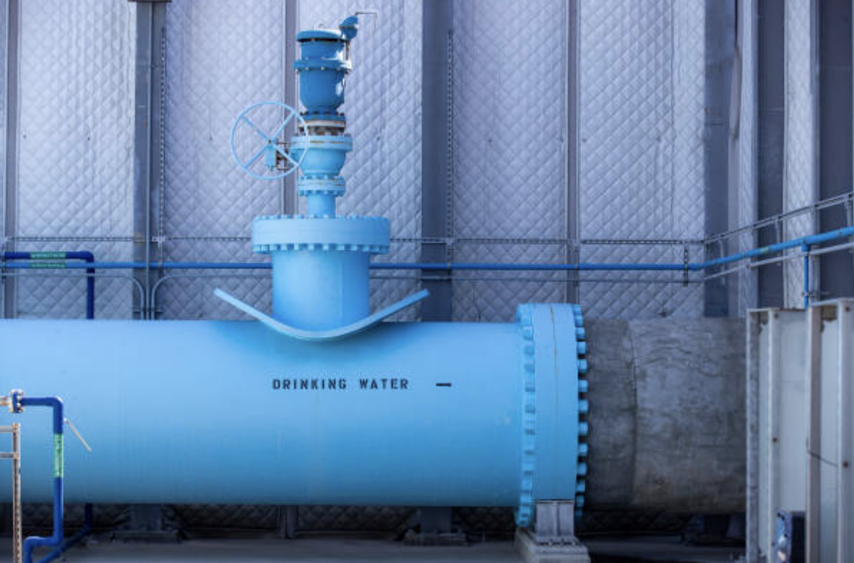
Photo: Getty Images

On Spain's Mediterranean coast, the Torrevieja desalination plant is crucial in providing
fresh water to the region, particularly during the summer tourist surge. The plant, the
largest in Europe, produces over 60 million gallons of water daily, supporting the local
population and agriculture, especially for citrus crops destined for Northern Europe.
Desalination is seen as a solution to water scarcity in arid regions, with countries like Saudi Arabia and the UAE heavily investing in these plants to support their rapidly growing cities.

Despite government subsidies, the high cost of desalinated water remains a burden for
farmers, and the discharge into the ocean from desalination plants of concentrated saltwater poses risks to marine life. While
Spain continues to invest in desalination, with plans to expand the Torrevieja plant,
critics argue that such facilities should be used primarily for drinking water during
droughts, not irrigation.

Full Article
“How Extreme Heat Is Threatening Education Progress Worldwide”

By: Somini Sengupta, The New York Times

Photo: Getty Images

On August 14, UNICEF released a report showing that today’s children are experiencing far hotter days than normal than their grandparents were living through at their age. As a result, more and more schools worldwide are closing for extended periods of time due to excessive heat, with tens of millions of Bangladeshi, Pakistani, and South Sudanese students being forced out of school over the spring. In the U.S., the number of school closures and early dismissals as a result of extreme heat is doubling, and is expected to continue increasing by 2050. In addition to heat waves, extreme floods are also causing school closures in parts of the world, including in Brazil and India. As a result, scientists recommend that school buildings better insulate themselves to keep heat out, although many schools cannot even afford to install proper air-conditioning.

Full Article
“Corn sweat: crop moisture amplifies humidity and heat in US midwest”
By: Erum Salam, The Guardian


Photo: Getty Images
Agriculture experts have pointed to crops such as corn as a reason for recent heat waves that have been occurring in the American Midwest. In the region, tens of millions of Americans are under extreme heat alerts, due in large part to the moisture in these crops that is released by them into the air. The Midwestern states of Illinois and Iowa in particular, which are engulfed in such alerts, produce ⅓ of all corn in the U.S., highlighting the fueling of the extreme heat in the region, with some temperatures ranging from 105 to 115 degrees Fahrenheit.

Full Article

“Mashantucket Pequot tribe receives $1.5 million for electric vehicles”
By: Jeniece Roman, WSHU

Photo: Getty Images
The Environmental Protection Agency (EPA) has recently announced that it will be awarding a $1.5 million grant to the Mashantucket Pequot Tribal Nation in Connecticut for them to replace their government vehicles with electric ones, and to install charging stations. Under the Inflation Reduction Act, the Climate Pollution Reduction Grants program was created, and the EPA has selected 34 applicants, including the tribe, to allocate grants towards for climate-related projects. Mashantucket environmental liaison Rahiem Eleazer projects that this project will take five years to complete, and that tribe residents will be given rebates for either buying electric vehicles or “provid[ing] educational programs.”

Full Article
“US Public EV Chargers Set to Surpass Gas Stations in Eight Years”
By: Kyle Stock, Bloomberg

Photo: Getty Images
In the second quarter, the U.S. added 704 new public fast-charging stations, a 9% increase, bringing the total to nearly 9,000 sites. This growth suggests that fast-charging stations could outnumber gas stations in about eight years, with North American investment in charging infrastructure set to reach $6.1 billion this year and double again by 2030. Major brands and retailers, including Shell and Waffle House, are expanding their networks to meet rising demand, driven by increasing EV sales and the need for faster charging.
The rapid growth in EV sales, with first-quarter numbers matching all of 2020, highlights the sector’s expansion. Charging stations are becoming more profitable, with an 18% utilization rate by the end of Q1. The Biden administration's National Electric Vehicle Infrastructure Formula program is crucial in boosting charger demand, though charging anxiety still remains a concern.
Full Article
Fare-Free Public Transit and its Impact on Climate Change
Alex Kawa (NGO Intern)

Background
Making public transit in urban areas fare-free is an idea that has gained much steam in recent years. In November 2023, the city council of Albuquerque, New Mexico, voted to eliminate fares for its city buses, becoming the largest city in the U.S. to do so, followed closely behind by Kansas City, Missouri. Furthermore, the Worcester Regional Transit Authority (WRTA) in Massachusetts voted in April 2024 to extend its fare-free program, which began four years prior as a result of the COVID-19 pandemic, until at least June 2025. Also in the Bay State, Boston’s mayor has supported the city’s pilot program on fare-free buses, expressing her desire to make it permanent citywide. As more and more cities opt to scrap the fares for their transit systems, or at least to test the impacts of doing so, fare-free public transit becomes a more viable and widespread method for reducing carbon emissions.

Notably, Germany has introduced a monthly transit ticket priced at $54.70, valid for all local and regional transportation, including trains, buses, and subway systems. This initiative aims to encourage public transport use and has garnered attention as a potential model for expanding access and reducing reliance on private vehicles.

Impacts
Expanded public transit is one of the many recommended solutions to meet emissions reduction targets. Recent climate reports from the United Nations have called it “essential” in the fight against the climate crisis. According to the World Resources Institute, expanded transit “can reduce greenhouse gas (GHG) emissions by up to two-thirds per passenger, per kilometer compared to private vehicles.”

This is why so many cities with public transit have opted for doing away with fares, and in many cases, the results have been promising. In Iowa City, Iowa, for instance, ever since the return to in-person meetings after Covid, ridership for its fare-free buses has steadily increased annually, including by 43% over the most recent fiscal year. Meanwhile, in Kansas City, the overwhelming majority of new riders took advantage of the fare-free system to see medical professionals, shop for groceries, get jobs, etc. By giving people the option to ride for free, these cities are decreasing the number of cars on the road, which goes a long way in reducing the number of carbon emissions.

Conclusion
As fare-free transit continues to be explored as a new policy in several urban areas, it is gaining ground as a tangible climate action. Where it has been implemented, it is very popular. For example, 70% of residents within the Worcester area supported the program. By increasing ridership, fewer cars and taxis will be on the road, and emissions will go down, all while more city residents will be able to access essential services fare free.

Sources
City of Albuquerque. (2024, January 4). Zero fares is here to stay. https://www.cabq.gov/transit/news/zero-fares-is-here-to-stay
Worcester Regional Transit Authority. (2024, April). WRTA board approved fare-free transit through June 2025. https://www.wrrb.org/news/2024/04/wrta-board-approved-fare-free-transit-through-june-2025/
Commonwealth Beacon. (2024, March 22). Wu plans to extend fare-free bus pilot. https://commonwealthbeacon.org/transportation/wu-plans-to-extend-fare-free-bus-pilot/
World Resources Institute. (2024, February 7). The current state of public transport and climate goals. https://www.wri.org/insights/current-state-of-public-transport-climate-goals
Press-Citizen. (2024, August 22). 1.5 million riders made use of Iowa City’s fare-free transit last year. https://www.press-citizen.com/story/news/local/2024/08/22/1-5-million-riders-made-use-of-iowa-citys-fare-free-transit-last-year/74891044007/
Next City. (2024, March 5). Kansas City’s zero-fare transit program shows major success. https://nextcity.org/urbanist-news/kansas-city-zero-fare-free-transit-program-shows-major-success
Streetsblog Mass. (2024, March 20). Poll finds overwhelming public support for Worcester’s fare-free buses. https://mass.streetsblog.org/2024/03/20/poll-finds-overwhelming-public-support-for-worcesters-fare-free-buses
Key International Environmental and Climate Change Initiatives
Nikolai Stephens-Zumbaum (NGO Intern)

The Intergovernmental Panel on Climate Change (IPCC) is a United Nations body
established in 1988. Its primary function is to assess the scientific, technical, and socio-economic
information relevant to understanding the risk of human-induced climate change. The IPCC
produces very detailed assessment reports, special reports, and technical papers, which are
important in shaping international climate policies, and are often used by governments, non profit and private sector bodies when making decisions. The panel's work is based on the voluntary contributions and work of thousands of scientists from around the world, making it a highly authoritative source of climate information.

The United Nations Sustainable Development Goals (UN SDGs) are a collection of 17
interconnected global goals designed to be a blueprint to achieve a better and more sustainable
future for all. Established in 2015 by the UN General Assembly, the goals cover a wide range of
issues, including poverty, inequality, climate change, environmental degradation, peace, and
justice. Each goal has specific targets to be achieved by 2030, emphasizing a holistic approach to
sustainability and the urgent need for coordinated action across different sectors and countries.

At NGO Sustainability, we are most focused on goals 7 (Affordable and Clean energy), 13
(Climate Action), 14 (Clean oceans), and 17 (Partnerships).

The United Nations High-Level Political Forum on Sustainable Development (UN
HLPF) is the main platform for the global follow-up and review of the 2030 Agenda for
Sustainable Development and the SDGs. The HLPF meets annually under the supervision of the
Economic and Social Council (ECOSOC) and every four years under the General Assembly. It
provides a space for member states and other stakeholders to share experiences, highlight
successes, and discuss challenges in implementing the SDGs. The forum plays a critical role in
promoting transparency, accountability, and mutual learning among nations. Essentially, they
discuss how the world is doing with trying to achieve the SDGs laid out, and is a place for
strategies to be shared amongst countries.

The United Nations Environment Programme (UNEP) is the leading global
environmental authority, established in 1972. UNEP sets the global environmental agenda,
promotes a coherent implementation of the environmental part of sustainable development
within the United Nations system, and serves as a overall advocate for the global environment.
It works on various issues such as climate change, biodiversity, and ecosystem management,
pollution, and sustainable consumption and production. UNEP’s work includes assessments,
policy advice, capacity building, and supporting the implementation of international
environmental agreements.

In 2024, Baku, Azerbaijan, will host the yearly climate change summit, COP 29, bringing
together world leaders, policymakers, scientists, and activists to discuss and advance global
efforts in combating climate change. The summit will focus on reviewing progress towards
international climate goals, including the 2015 Paris Agreement targets, and exploring innovative
solutions for mitigating and adapting to climate impacts. Key topics are expected to include
renewable energy advancements, financing for climate initiatives, technology transfer, and
strengthening resilience in vulnerable communities. The Baku summit aims to foster
international cooperation and accelerate action to address the urgent climate crisis.
The previous climate change summit held in Dubai in 2023, known as COP28, was an
important event for global climate action. Key outcomes included the adoption of new
commitments to reduce greenhouse gas emissions, significant pledges for climate finance aimed
at supporting developing nations, and a strong emphasis on accelerating the transition to
renewable energy. The summit also focused on enhancing climate resilience and adaptation
strategies, with extensive discussions on innovative solutions and technologies to address climate
impacts. Additionally, COP28 facilitated important dialogues on the importance of aligning
national policies with the goals of the Paris Agreement, aiming to limit global warming to well
below 2 degrees Celsius.

The IPCC, UN SDGs, UN HLPF, UNEP, and the upcoming climate change summit in
Baku represent critical components of the global framework for addressing environmental
challenges and promoting sustainable development. The IPCC's scientific assessments inform
policy decisions and international negotiations on climate change. The SDGs provide a
comprehensive and integrated approach to achieving a sustainable future by 2030, addressing a
wide range of social, economic, and environmental issues. The HLPF ensures that progress is assessed and monitored each year, and that best practices are shared among nations. UNEP leads
global efforts to address environmental challenges through policy guidance, capacity building,
and advocacy. The climate change summit in Baku will be a critical event for galvanizing
international action, enhancing collaboration, and exploring innovative solutions to meet climate
goals, especially climate finance. Together, these initiatives underscore the importance of coordinated efforts, scientific guidance, and international cooperation in tackling the complex and interconnected issues of climate change and sustainability.

Sources:
Intergovernmental Panel on Climate Change. (n.d.). Home. https://www.ipcc.ch/
Wikipedia contributors. (2024, September 20). Intergovernmental Panel on Climate Change. In Wikipedia, The Free Encyclopedia. https://en.wikipedia.org/wiki/Intergovernmental_Panel_on_Climate_Change
United Nations Framework Convention on Climate Change. (2023). About COP 28. https://unfccc.int/process-and-meetings/conferences/un-climate-change-conference-united-arab-emirates-nov/dec-2023/about-cop-28
United Nations Framework Convention on Climate Change. (n.d.). COP 29. https://unfccc.int/cop29
United Nations. (n.d.). Sustainable Development Goals. https://sdgs.un.org/goals
United Nations. (n.d.). High-level Political Forum on Sustainable Development. https://hlpf.un.org/
United Nations Environment Programme. (n.d.). Climate action. https://www.unep.org/topics/climate-action?gad_source=1
Producer: Roma Stibravy, NGO Sustainability President
Editors: Adrianna Mannino, Columbia University School of Professional Studies
Contributors: NGO Sustainability Interns and Associates

Corporate Sponsors




MAKE A DIFFERENCE!
BECOME A MEMBER OF NGO SUSTAINABILITY!
SEE CORPORATE SPONSORSHIP OPPORTUNITIES
unngosustainability.org

Jordan Sanchez. "Burning Earth", 2019. https://thejordansanchez.com/2021/05/25/burning-earth/

