**` **

**NGO SUSTAINABILITY**

GLOBAL WARNING +1.2°C

*LATEST NEWS IN SUSTAINABILITY*

*NO. 149 | March 2024*

PROMOTING SUSTAINABLE LIVING AND RENEWABLE ENERGY FOR THE FUTURE OF OUR PLANET

[ngosustainability@gmail.com](mailto:ngosustainability@gmail.com) | [unngosustainability.org](https://www.unngosustainability.org)

Consultative Status, the United Nations Economic and Social Council (ECOSOC)

Observer Status, United Nations Environment Programme (UNEP)

*Your comments are always welcome.*

*Please feel free to reproduce and share with your colleagues.*

*- NGO Sustainability team*

"The Waterhouse"

Paul Bond

# [www.paulbondart.com](http://www.paulbondart.com/)

# 

# ***On the Grasshopper and Cricket* By John Keats[1]**

# The poetry of earth is never dead: When all the birds are faint with the hot sun, And hide in cooling trees, a voice will run From hedge to hedge about the new-mown mead; That is the Grasshopper’s–he takes the lead In summer luxury,–he has never done With his delights; for when tired out with fun He rests at ease beneath some pleasant weed. The poetry of earth is ceasing never: On a lone winter evening, when the frost Has wrought a silence, from the stove there shrills The Cricket’s song, in warmth increasing ever, And seems to one in drowsiness half lost, The Grasshopper’s among some grassy hills.

**“Tracking an Invisible Climate Menace From 360 Miles Above”**

By: Malika Khurana and Hiroko Tabuchi, *The New York Times*



*Photo: Getty Images*

MethaneSAT, a satellite designed to track methane emissions on a global scale, was

launched by the Environmental Defense Fund. Methane is a highly potent greenhouse gas that

contributes significantly to climate change, is emitted from landfills, agricultural activities and

oil and gas operations. MethaneSAT, which is funded by philanthropic donations, tries to provide accurate and precise information on methane emissions to detect leaks faster. It is equipped with very advanced instruments to detect small changes in methane concentrations in wide areas. MethaneSAT is backed by Google, which plans to make the data public to empower stakeholders in holding polluters accountable. The launch marks a major step toward regulating methane emissions and reducing methane related climate impacts.

[Full Article](https://www.nytimes.com/interactive/2024/03/03/climate/methane-satellite-launch-global-warming.html)

**“British Airways owner IAG signs biggest ever deal for sustainable aviation fuel of nearly 1 billion litres”**

By: *ESG News *

*Photo:* *Getty Images*Together with Twelve, a leader in e-Sustainable Aviation Fuel (SAF), International Airlines

Group (IAG) signed its largest SAF deal, making a large move towards reducing emissions. Under this 14 year deal, Twelve will provide IAG with 785,000 tons of e-SAF to bolster its five European airlines. This fuel is made from CO2, water, and renewable energy, providing the possibility of a 90% reduction in lifecycling greenhouse gas emissions compared to the standard jet fuel. IAG’s dedication to SAF is highly evident by obtaining 12% of the global supply in 2023. IAG’s ambition to achieve 10% SAF usage by 2030 is very evident through this

collaboration with Twelve, and hopefully in the future other airlines companies will follow in

their footsteps.

[Full Article](https://esgnews.com/british-airways-owner-iag-signs-biggest-ever-deal-for-sustainable-aviation-fuel-of-nearly-1-billion-litres/)

**“Fewer Monarch Butterflies At Mexico Wintering Areas”**

By: Catrin Einhorn, *New York Times*



*Photo: Getty Images*

The number of Monarch Butterflies recorded at their overwintering area in Mexico dropped 59% this year, resulting in the second lowest levels ever recorded. Scientists say the decline is likely due to the hot and dry conditions seen in the US and Canada, which reduced the quality and availability of Milkweed, the only plant Monarch Caterpillars can eat. These findings have caused the butterfly’s status on the International Union for Conservation of Nature Red List of Threatened Species to be vulnerable, or threatened with extinction. One Monarch Scientist says that to a degree, fluctuations in insect populations are to be expected, and Monarchs specifically can bounce back from extremely low numbers. The determining factor will be plant and resource availability in the Spring.

[Full Article](https://www.nytimes.com/2024/02/07/climate/monarch-butterflies.html)

**“Wind turbines are friendlier to birds than oil-and-gas drilling**”

By: *The Economist  
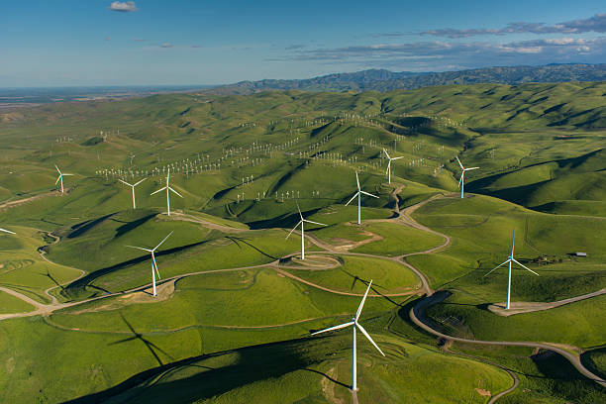*

*Photo: Getty Images*

Media coverage often emphasizes the perceived negative impact of wind turbines on birds However, a recent analysis of American bird data challenges these concerns about wind turbines' impact on bird populations. Published in Environmental Science & Technology, the study by economist Erik Katovich from the University of Geneva used the Christmas Bird Count, a century-spanning citizen-science project. Contrary to previous fears, the construction of wind turbines has had negligible impacts on bird populations. In fact, the study revealed a 15% drop in bird numbers associated with new oil and gas wells, rising to 25% in designated "important bird areas." The findings suggest that wind power, emitting fewer greenhouse gases, poses less harm to wildlife compared to fossil fuels.

[Full Article](https://www.economist.com/science-and-technology/2024/01/10/wind-turbines-are-friendlier-to-birds-than-oil-and-gas-drilling)

**“European carbon tariffs take their first steps”**

By: Francisco de Zárate, *El País*



*Photo: Getty Images*

Starting in January 2024, the European Union implemented a new carbon tariff called the Carbon Border Adjustment Mechanism (CBAM). The primary objective of this tariff is to address global warming by levying taxes on the surplus of emissions rights paid within the EU compared to those paid outside the EU, thereby ensuring a level playing field for European industrialists. Countries such as the US, Canada, Australia, and the UK are considering implementing similar measures. However, there are concerns about bureaucratic hurdles, differing emission measurement standards, and potential trade conflicts that can arise with the implementation of the tariff. The European Commission plans to evaluate the effectiveness of CBAM in 2025, which may lead to an expansion of the tariff to other sectors.

[Full Article](https://www.google.com/url?q=https://elpais.com/economia/negocios/2024-03-06/los-aranceles-europeos-al-carbono-dan-sus-primeros-pasos.html&sa=D&source=docs&ust=1710991541510423&usg=AOvVaw14X6raWvXmINsKtB7-J2_6)

**“How Unilever uses AI to cut petrochemicals out of laundry soap”**

By: Heather Clancy, *GreenBiz*

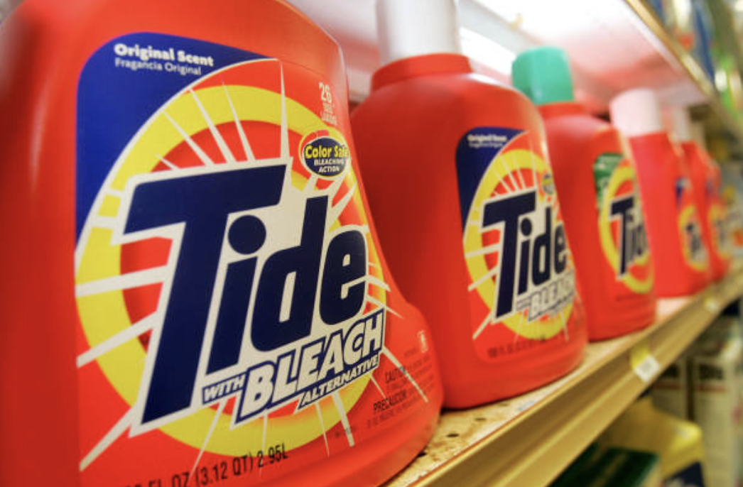

*Photo: Getty Images*

Unilever accelerates the replacement of petrochemicals in its cleaning and laundry products using artificial intelligence (AI). Partnering with Arzeda, they have identified renewable and biodegradable enzymes that decarbonize products such as OMO detergent. Within 18 months, they discovered the enzymes that remove stains while conserving energy and water, potentially halving ingredient usage. This collaboration, five times faster than traditional methods, involves physicists, biologists, and data analysts, emphasizing a concerted effort to revolutionize product development. With tangible outcomes in mind, Unilever aims for net-zero carbon emissions by 2039 and biodegradable formulations by 2030.

[Full Article](https://www.greenbiz.com/article/secret-ingredient-speeding-unilevers-development-cleaner-laundry-detergent-ai)

**“Microsoft, P&G, Unilever, and Walmart among 239 companies to miss net-zero deadline”**

By: Heather Clancy, *GreenBiz*



*Photo: Getty Images*The Science Based Targets initiative recently downgraded 239 companies, such as Microsoft, P&G, Unilever, and Walmart, to "commitment removed" status for failing to submit science-based net-zero emissions targets. Despite this, the companies remain committed to aggressive emissions reduction goals. There are challenges in meeting SBTi's standards, particularly regarding Scope 3 emissions. SBTi is reviewing its Corporate Net-Zero Standard, with changes expected by 2025, including revisions related to Scope 3 target setting and measurement. While the "commitment removed" label can be reversed, it highlights the complexities corporations face in aligning with ambitious climate goals.

[Full Article](https://www.greenbiz.com/article/microsoft-pg-unilever-and-walmart-among-239-companies-miss-net-zero-deadline)

**“World must move beyond waste era and turn rubbish into resource: UN Report”**

By: *UN Environment Programme*



*Photo:* *Getty Images*

The UN Environment Programme warns of a looming waste crisis, with municipal waste predicted to rise by two-thirds and costs to nearly double by 2050. Urgent action is needed to decouple waste generation from economic growth and transition to zero waste and circular economy approaches. Without intervention, global waste management costs could soar to over USD 600 billion annually by 2050, severely impacting human health, economies, and the environment. The report underscores the critical role of decision-makers in driving transformative solutions and calls for bold action to prevent missed opportunities for sustainable development. Launched at the UN Environment Assembly, the report urges strong leadership to accelerate the transition to a zero waste future and ensure global sustainability.

[Full Article](https://www.unep.org/news-and-stories/press-release/world-must-move-beyond-waste-era-and-turn-rubbish-resource-un-report)

Environmental Organization Report:

Woods Hole Oceanographic Institution

Adrianna Mannino (NGO Intern)

The Woods Hole Oceanographic Institution (WHOI) is an independent non-profit organization dedicated to the study of marine science and engineering in Woods Hole, Massachusetts. Founded in 1930, WHOI has a wide range of research topics including interdisciplinary work related to the coastal ocean, ocean exploration, and climate change. Many scientists and engineers who come from this organization have laid the foundation for many of the discoveries that revolutionized our understanding of the ocean and its impact on our lives.   
  
**Vision & Mission:**WHOI commits to understanding all aspects of the ocean and its relationship with Earth’s land, seafloor, ice, atmosphere, and humanity. This is imperative to help humans on the planet become environmentally conscious while advancing knowledge about our planet. WHOI is dedicated to advancing understanding of the ocean, its Earth system, and applying this knowledge to help mitigate problems that face society today. whoi trains future generations of scientist idk

**Leadership:**The organization’s current president and director is Peter B. de Menocal. He is a distinguished marine geologist and paleoclimatologist, whose research is focused on utilizing deep sea ocean sediments in order to understand Earth’s past climate and oceanic changes to aid in predicting future shifts. In addition to leading WHOI, he has held esteemed positions at Columbia University, including Founding Director of the Center for Climate and Life and Dean of Science for the Faculty of Arts and Sciences.   
  
**Current Projects:**WHOI has a great variety of different science and engineering projects that are currently being executed in many different areas in the United States.

- **Autonomous Vehicles and Sensor Technologies (AVAST):** AVAST facilitates the advancement of ocean technology and research, educating future ocean technologists and scientists, and addressing societal challenges.

- **Marine Microplastics Initiative:** This interdisciplinary research endeavor aims to understand the complexities of plastic pollution in marine environments, exploring its impacts on marine life and human health, while also developing exciting and effective technological solutions.

- **The Loc-NESS Project:** This project aims to discover the potential of ocean chemistry to combat climate change. Using Ocean Alkalinity Enhancement (OAE), a method aimed at enhancing the ocean’s natural capacity to absorb carbon dioxide from the atmosphere, researchers are trying to stabilize Earth’s climate cycle and mitigate climate change. These experiments take non-toxic fluorescent dye and release it into the ocean to model the dispersion of alkalinity, in order to provide crucial insights into the behavior of alkalinity enhanced water patches.

- **Ocean & Climate Innovation Accelerator:** This project brings together industry, academia, and philanthropy to further and activate new ocean-based climate change solutions.

synthesis well written fashion

United Nations Ocean Conference (UNOC) 2025

*Paula Grandas (NGO Intern)*

The third United Nations Ocean Conference (UNOC) is scheduled to take place in Nice, France, from June 9 to June 13, 2025. The conference will be led by France and Costa Rica. The theme of the conference is ‘Accelerating action and mobilizing all actors to conserve and sustainably use the ocean’. The objective is to generate transformative initiatives and offer solutions essential for the ocean's well-being, supported by oceanic research and funding aimed at achieving Sustainable Development Goal (SDG) 14, which is to conserve and sustainably use the oceans, seas, and marine resources for sustainable development.

The United Nations and French President Emmanuel Macron have chosen Nice to host UNOC 2025. President Macron shared the news on Twitter, saying “Our ambition is to reach an agreement to protect the ocean as a common good of humanity”. The city of Nice was selected due to its commitment to preserving marine environments, as stated by Christian Estrosi, the Mayor of Nice.

The ‘Call to All Voices of the Ocean’, a stakeholder meeting that includes NGO participation, will precede UNOC 2025. This meeting is set to take place in Costa Rica in June 2024. In preparation for this meeting, all civil society organizations were encouraged to send feedback and expectations for the upcoming Conference between April 2023 and June 2023. Contributions were based on five questions:

1. What would you replicate and what would you do differently in comparison to the previous Conferences?
2. As NGOs, how do you want to position yourselves, and how do you want to be remembered for your participation at the 3rd UN Ocean conference?
3. What are your 3 to 5 key deliverables for the 3rd UN Ocean Conference (e.g. in terms of public policy, governance, finance, science, innovation)?
4. As ocean advocates, where do you want to bring governments and the private sector, and how do you propose to bring them on board to uplift SDG14?
5. Do you think the 3rd UN Ocean Conference should provide an opportunity to identify action beyond SDG 14, five years before 2030?

The outcome of the survey was that most civil society organizations expect the adoption of a moratorium or a ban on deep-sea mining, the entry of force of the High Seas Treaty, the implementation of a legally binding Plastic Treaty, inclusion of oceans in national strategies, and the protection of the Southern Ocean.

The UN Ocean Conference 2025 will bring together various actors, including Governments, the United Nations system, intergovernmental organizations, international financial institutions, non-governmental organizations, civil society organizations, academic institutions, the scientific community, the private sector, philanthropic organizations, Indigenous Peoples, and local communities. The Conference will comprise an opening segment, ten plenary sessions, ten Ocean Action Panels and a closing segment to evaluate the obstacles and possibilities related to the implementation of Goal 14 and the actions undertaken towards its fulfillment and ultimately adopt a declaration and a list of voluntary commitments under the label ‘Nice Ocean Action Plan’.

**References**

Loreley Picourt, Ocean & Climate Platform, and Rémi Parmentier, The Varda Group. (2023). Outcomes from the Civil Society Consulations. Retrieved from https://ocean-climate.org/wp-content/uploads/2023/10/Executive-Summary_CSO-global-consultation-in-preparation-of-UNOC-2025_VDEF.pdf

Nice Côte d'Azur. (2023). 2025: The United Nations Ocean Conference Will Be Held In Nice. Retrieved from Nice Côte d'Azur: https://www.explorenicecotedazur.com/en/news/2025-the-united-nations-ocean-conference-in-nice/

Ocean & Climate Platform. (2023). UNITED NATIONS OCEAN CONFERENCE 2025. Retrieved from Ocean & Climate Platform: https://ocean-climate.org/en/unoc2025/

Ocean & Climate Platform, The Varda Group. (2023). A Call to All the Voices of the Ocean. Retrieved from https://ocean-climate.org/wp-content/uploads/2023/10/SYNTHESIS-REPORT-A-Call-to-All-the-Voices.pdf

United Nations. (n/a). 2025 UN Ocean Conference. Retrieved from United Nations: https://sdgs.un.org/conferences/ocean2025

Producer: Roma Stibravy, President

Editors: Catie Eiref - Columbia University Mailman School of Public Health

Adrianna Mannino - Stony Brook University School of Marine and Atmospheric Sciences

Contributors: NGO Sustainability Interns

**BECOME A MEMBER OF NGO SUSTAINABILITY!**

**SEE CORPORATE SPONSORSHIP OPPORTUNITIES**

[unngosustainability.org](http://unngosustainability.org)

1. John Keats. "On the Grasshopper and Cricket", 1816. https://www.poetryfoundation.org/poems/53210/on-the-grasshopper-and-cricket.