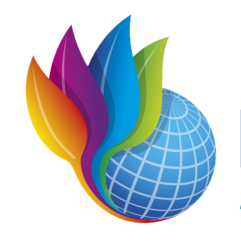
`
NGO SUSTAINABILITY
GLOBAL WARNING +1.2°C
LATEST NEWS IN SUSTAINABILITY
NO. 151 | May 2024
PROMOTING SUSTAINABLE LIVING AND RENEWABLE ENERGY FOR THE FUTURE OF OUR PLANET
ngosustainability@gmail.com | unngosustainability.org

Consultative Status, the United Nations Economic and Social Council (ECOSOC)
Observer Status, United Nations Environment Programme (UNEP)

Your comments are always welcome.
Please feel free to reproduce and share with your colleagues.
- NGO Sustainability Team
“High quality water is more than the dream of the conservationists, more than a political slogan; high quality water, in the right quantity at the right place at the right time, is essential to health, recreation, and economic growth.”
– Edmund S. Muskie, Former US Secretary of State and US Senator, introducing the Clean Water Act to US Congress in 1971
John Podesta

John Podesta was appointed as the US Special Presidential Envoy for Climate in March 2024, succeeding John Kerry. In this role, Podesta is responsible for coordinating US international climate strategy and representing the US in global climate negotiations, working to strengthen international commitments to reduce greenhouse gas emissions and promote sustainable development. Podesta has helped reengage the US with the Paris Agreement and foster international collaboration and has been pushing for ambitious climate goals, including supporting technological innovation in clean energy and addressing the intersection of climate change and national security.
Previously he has served as the White House Chief of Staff under President Bill Clinton as well as senior advisor on climate change and energy policy to President Barack Obama.

Podesta speaking at White House Conservation in Action Summit. Source: Getty Images
Podesta is also a co-founder of the Center for American Progress, a public policy research and advocacy organization that focuses on sustainable energy and climate initiatives. His efforts have been key in shaping progressive climate policies and advancing renewable energy initiatives.

Shadows in the Glass
By Sam Illingworth

Water runs clear,

a seeming serenity

caught in the half-light

of tasteless threats

and silent screams.

It lingers,

patient as a poacher’s line

to seep

from treatment’s cracks

unfiltered,

unsealed,

untamed.

A toxic residue

that chokes the flow,

spoiling souls

before their blooming –

distortions

of the heart’s first labour.

Heed the far bankside

where these drowsed serpents

coil among the reeds

their fangs brine the springs,

their venom our end.
“EPA Rules PFAS Must Be Removed From Drinking Water”
By: Vincent Gabrielle, Stamford Advocate 
Photo: Getty Images
With the Environmental Protection Agency’s (EPA) new rule to regulate Per- and Polyfluoroalkyl Substances (PFAS) in drinking water, there will be protection through enforceable limits. PFAS are synthetic chemicals which are often used in consumer products and fire retardants. PFAS are persistent in the environment and have been linked to human health impacts, including cancers. The Interagency PFAS Task Force in Connecticut acknowledges the public health threat, and was established in 2019 after an event at the Bradley International Airport where firefighting foam chemicals were spilled into the Farmington River. The new limits would be 0.004 parts per trillion for PFOS and PFOAs, and that is also the lowest limit technologically possible to measure. The designated limit for completing monitoring for the chemicals in public water systems is three years and updates for filters are required within two years of detecting PFAS. While the national remediation and monitoring for contamination may cost around $1.5 billion annually, according to the EPA, the Biden administration has set aside $1 billion to offset local testing and treatment efforts. There was recent litigation against local water companies as well as by local governments against PFAS manufacturers.
Full Article
“E.P.A. Will Make Polluters Pay to Clean Up Two ‘Forever Chemicals’”
By: Coral Davenport, The New York Times
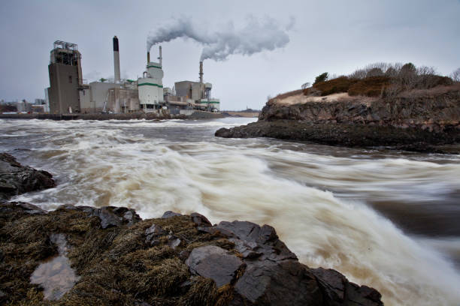
Photo: Getty Images
The new EPA rule provisions for the government to require monitoring perfluorooctanoic acid, or PFOA, and perfluorooctanesulfonic acid, PFOS via reports of releases that meet or are over one pound within a day to the National Response Center, state, local and tribal emergency responders. They also can be liable for cleaning up the pollution and a notice is required in the transfer or exchange of federal property, of release, storage or disposal and cleanup. With designation under the Superfund authority, the EPA can act earlier and expedite cleanups. The substances are found in children’s toys and the EPA states they are linked to metabolic disorders and types of cancers, such as prostate or kidney. PFAS are in almost 50% tap water in the US, and almost all levels of exposure are considered unsafe. Recently, there was a mandate to reduce PFAS in drinking water to near-zero.
Full Article

“Communities of Color Disproportionately Exposed to PFAS in Drinking Water, Study Says”
By: Jacob Knutson, Axios
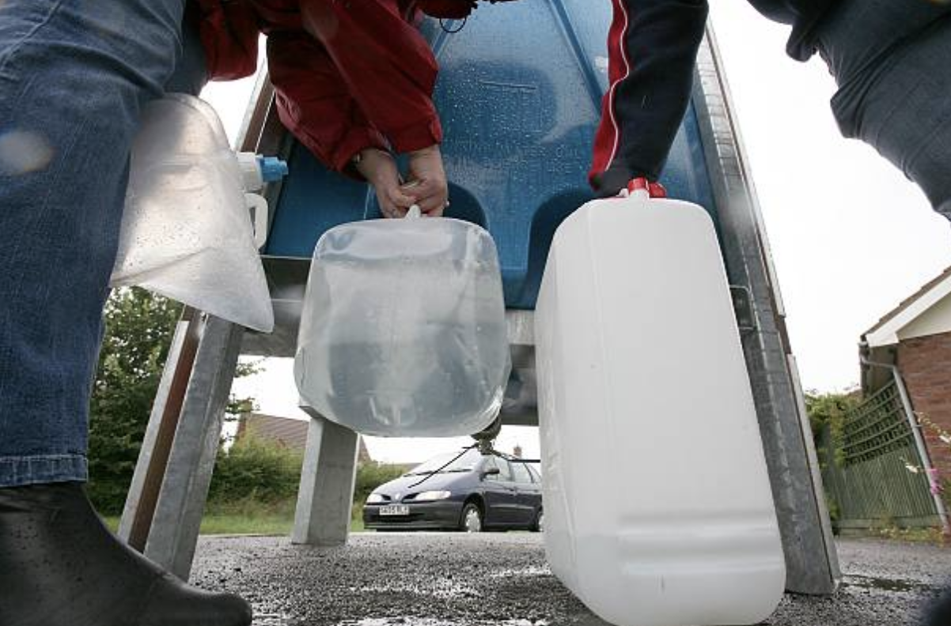
Photo: Getty Images

PFAS, also known as “forever chemicals”, are found in drinking water all over the world, but a new study shows that communities of color and low-income are disproportionately impacted by PFAS in their drinking water. The EPA has recently released new standards for these chemicals in the water. PFAS are found in products that are nonstick, oil and water repellent, and fire resistant. They can bioaccumulate in humans, fish, livestock, and plants if in our water sources. These PFAS can be harmful to human and animal health in high concentrations. The study showed that watersheds with high concentrations of PFAS were more likely to be provided to Hispanic and Black communities for drinking water, potentially widening already existing health disparities.
Full Article

“The impacts of toxic ‘forever chemicals’ aren’t the same for women, men”
By: Sharon Udasin and Rachel Frazin, The Hill
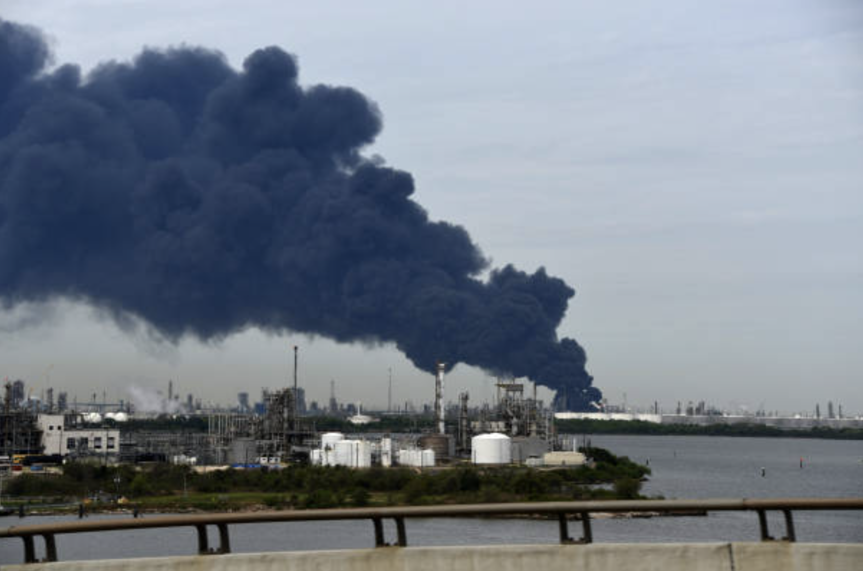

Photo: Getty Images
Various studies and toxicologic reports have investigated the implications of toxic forever chemicals according to sex. Women exposed to PFAS are associated with reproductive system issues, such as birth defects or alteration of the menstrual cycle. Also, it seems that women exposed to PFAS tend to be more prone to hormone-related cancers, high blood pressure, and cardiovascular diseases when compared to men. Others suggest that the impact of PFAS in women and girls is linked with ADHD, and may lead to weight gain and developing diabetes. In men and boys it has been found that PFAS may decrease bone density.

Full Article

“E.P.A. Severely Limits Pollution From Coal-Burning Power Plants”
By Lisa Friedman & Coral Davenport, The New York Times
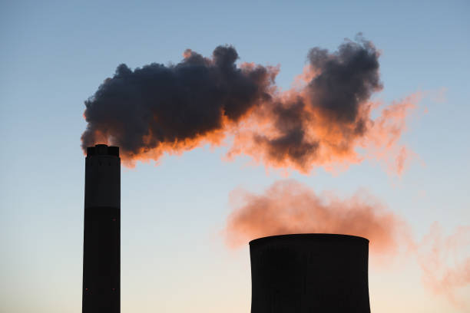
Photo: Getty Images

The Biden administration has placed a regulation that could decrease the number of plants that burn coal, the most polluting fossil fuel. The Environmental Protection Agency is now requiring that existing coal plants operating through or beyond 2039 must reduce their emissions 90 percent by 2032. Furthermore, the regulation will restrict emissions of mercury, discharge of wastewater, and seepage of toxic ash into water supplies. The EPA estimates that with these measures, 1.38 billion metric tons of CO2 could be reduced between now and 2047, in turn reducing health issues and carbon emissions. This new regulation is part of Biden’s bigger plan to cut 50% of pollution from 2005 levels by 2030 and move the country towards renewable energy.

Full Article
“Latin America and the Caribbean generated 62% of its electricity with renewables in 2023”
By: Jorge Vaquero Simancas, El País
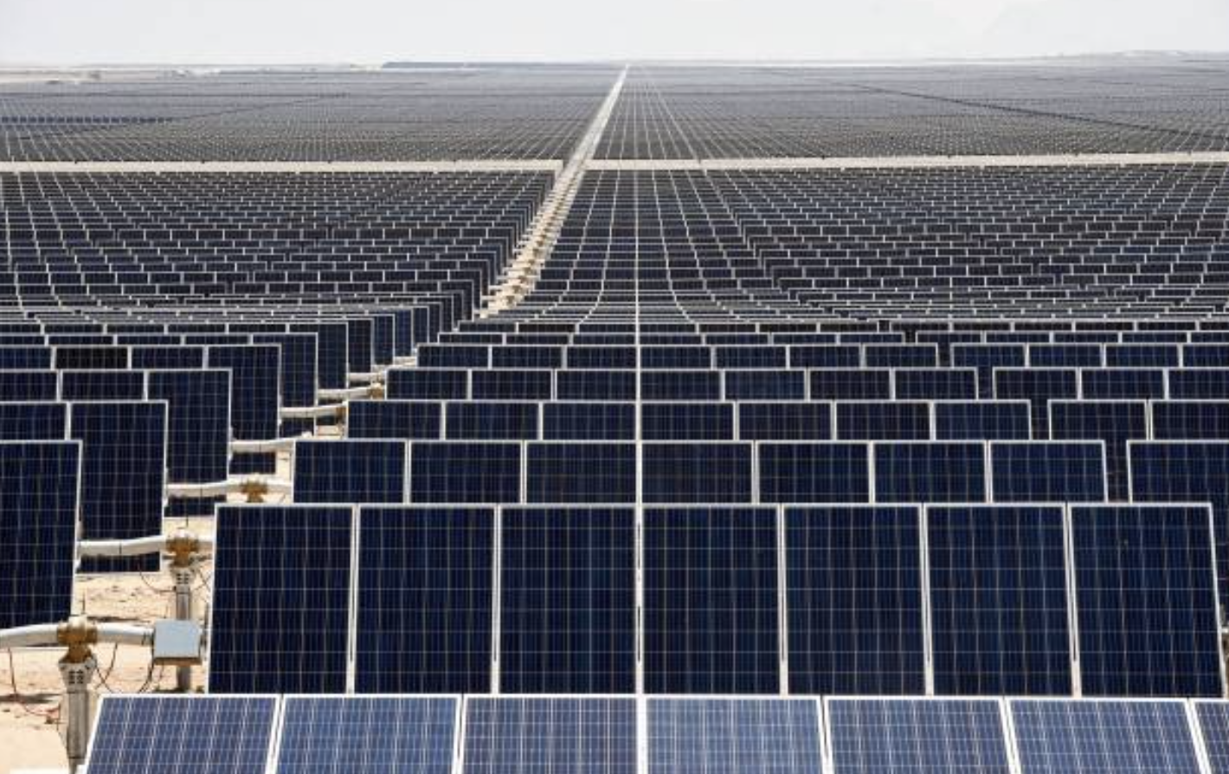

Photo: Getty Images
According to a report by Global Electricity, Latin America and the Caribbean are the leaders in renewable energy, generating 62% of energy from renewable sources. In Latin America hydroelectric power is the most prominent, supplying 43% of electricity, followed by wind and solar energy, with 8% and 6%, respectively. The combination of solar and hydroelectric plants has helped allow the region to develop without the use of coal, which supplies only 5% of the energy in the region. Continuing to develop renewable sources will be critical to keep up with increasing energy demands without using natural gas and other fossil fuels.

Full Article

“FERC shakes up power industry with landmark grid rule”
By: Zach Bright, Politico
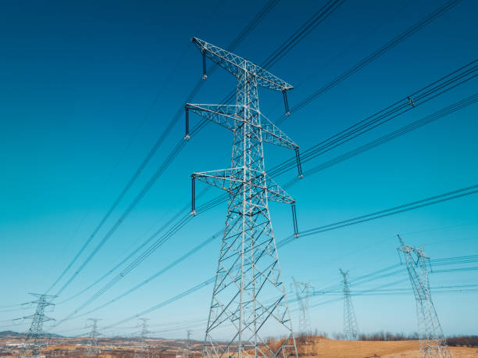
Photo: Getty Images
Earlier in May, federal energy regulators directed U.S. electricity grid operators to plan new transmission infrastructure that can deliver more renewable energy and defend against extreme weather. Biden administration officials have said the existing regional transmission capacity needs to double if we want to achieve the goal of cutting carbon pollution by 2035. In this new order, FERC established requirements for how costs of building high voltage power lines should be allocated among customers, further disrupting the issue of regional infrastructure and state guidelines. The FERC also passed a rule that gives it the authority to grant permits to electric transmission lines in certain instances where states do not act first.

Full Article

“Is It Time to Stop Wasting Waste?”
By: Jane Withers, New York Times
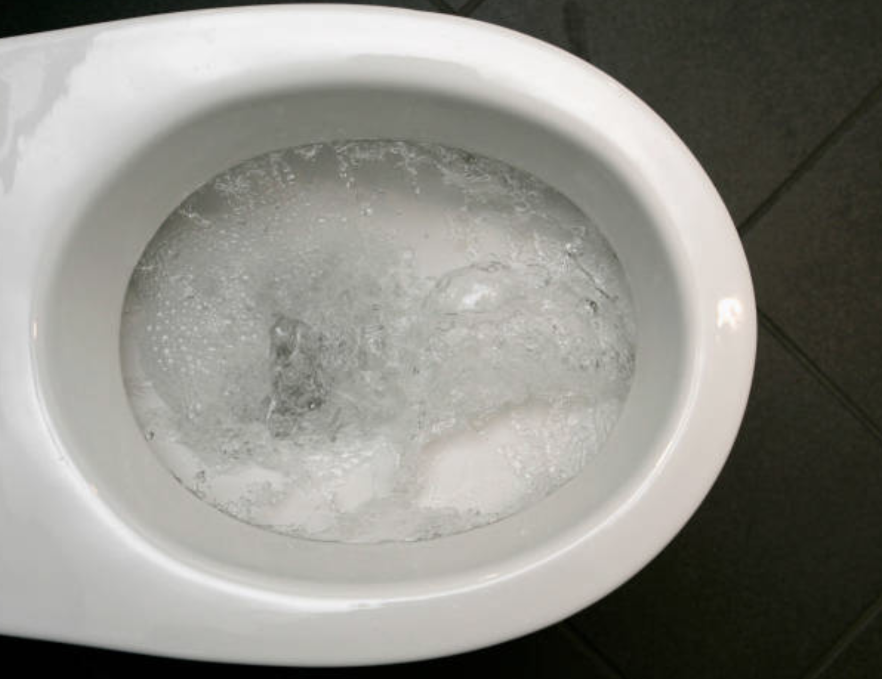

Photo: Getty Images
By flushing away human nutrients we are using significant amounts of fresh water. With climate change and water scarcity, there are new initiatives to staunch the flow of flushed water. In Germany, there is a system to reuse wastewater from rainwater, kitchens, and toilets that reduces water consumption by 30% while also generating electricity. There has even been a new debate on how to reuse human waste. Although the public is reticent and there are doubts about safety, there are several projects in Kenya, Germany, and Ghana that convert urine into fuel, garden fertilizer, and compost, respectively.

Full Article

Information on Per- and Polyfluoroalkyl Substances (PFAS)
Adrianna Mannino (NGO Intern)

What is PFAS?

Per- and polyfluoroalkyl substances (PFAS) are man made chemicals that have been widely used in various industries since the 1940s. PFAS are known for their water and grease resistant properties, and are found in numerous consumer products, such as nonstick cookware, food packaging, and water-repellent clothing. However, these chemicals are very difficult to break down in the environment and the human body, which gives them the nickname "forever chemicals”.

Health and Environmental Risks

PFAS pose significant risks to human health and the environment. Exposure to some PFAS compounds has been linked to a range of serious health problems, including increased risk of cancers such as kidney and testicular cancer, hormone disruption, liver and thyroid disease, reproductive harm, and impaired immune function. The persistence of PFAS in the environment means they can accumulate in water, soil, and living organisms, leading to widespread contamination.

Widespread Contamination

The widespread use of PFAS has led to their presence in water systems across the United States and globally. The Environmental Protection Agency (EPA) has found PFAS in water, air, fish, and soil. The EPA's ongoing review of water systems revealed that at least 70 million Americans are served by systems with PFAS contamination levels requiring reporting. Major cities like Salt Lake City, Sacramento, Madison, and Louisville have reported significant PFAS contamination.

What is the EPA Doing to Address this Crisis?

- The EPA has proposed the first-ever national drinking water standard for six PFAS compounds, including PFOA and PFOS. These standards aim to enforce limits on PFAS levels in public water systems and require utilities to take action if these limits are exceeded.
- The EPA is conducting extensive research to better understand the health effects of PFAS, improve detection methods, and develop strategies for managing and disposing of these chemicals.
- The EPA is committed to providing clear, actionable information to the public about PFAS. This includes detailed reports on health risks, contamination sites, and steps individuals can take to reduce their exposure.

Challenges in Addressing PFAS

Addressing PFAS contamination is difficult due to the vast number of chemicals in this class and their prevalent use in consumer products. Detecting and measuring PFAS in various environmental samples is challenging, along with developing effective treatment methods to remove these chemicals from drinking water and other sources.

Steps for Consumers

- Request PFAS testing data from local water providers. If contamination is detected, advocate for the installation of appropriate treatment systems.
- Certain home water filters, such as reverse osmosis and granular activated carbon filters, can reduce PFAS levels in drinking water.
- Avoid products labeled as water or stain resistant, as these are likely to contain PFAS. Opt for stainless steel, cast iron, glass, or ceramic cookware instead of nonstick alternatives.

References:
“EPA Imposes First National Limits on ‘forever Chemicals’ in Drinking Water.” NBC News, 10 Apr. 2024, www.nbcnews.com/health/health-news/epa-limits-pfas-chemicals-drinking-water-first-time-rcna147000.

“Forever Chemicals” Called PFAS Show up in Your Food, Clothes, and Home. 10 Apr. 2024, www.nrdc.org/stories/forever-chemicals-called-pfas-show-your-food-clothes-and-home.

“PFAS Explained | US EPA.” US EPA, 25 Oct. 2023, www.epa.gov/pfas/pfas-explained.

Today, Usa. “70 Million Americans Drink Water From Systems Reporting PFAS to EPA. Is Yours on Our Map?” USA TODAY, 2 May 2024, www.usatoday.com/story/news/investigations/2024/03/21/pfas-forever-chemicals-drinking-water-epa/72972769007.
The Boy Who Harnessed the Wind: Creating Currents of Electricity and Hope
By: William Kamkwamba and Bryan Mealer

Paula Grandas (NGO Intern)
The Boy Who Harnessed the Wind: Creating Currents of Electricity and Hope, is an autobiographical science book written by William Kamkwamba and Bryan Mealer. The novel tells the story of William Kamkwamba, a 13-year-old boy from Malawi who was able to produce electricity for his village using a windmill.

In the Malawian village where William lived, a radio was the only object that used electricity.. By exploring its inner workings and reading library books, William became interested in engineering and energy. During this time, William discovered the bicycle dynamo, a device which can be attached to a bike wheel that converts kinetic energy generated from the spinning wheel into electricity. He was fascinated by how pedaling could generate light and began creating electricity using broken materials from dumps.
In 2001, a severe drought devastated Malawi, leading to long periods of crop loss, hunger, and severe economic instability. During this time, William came up with a plan to provide water to his family’s farm. Envisioning the bicycle dynamo, he decided to create a windmill to pump water. “The movement energy is provided by the rider (…) and the rider is the wind!” Electricity was a luxury that few Malawians could afford. But William and his village needed it to survive. So, he knew if he could create a large enough windmill, he could generate as much electricity as a power plant and bring light and water all year round.
William and his friends collected thrown away materials and started to build a small model. After some success, he decided to scale up the project. Despite the criticism and much effort, they bought a generator, and built a tower windmill out of scrap pieces. The windmill was able to produce light. Several years later, William finally constructed a large enough windmill that was also able to provide running water to his family’s farm.
In William’s words, “If you want to make it, all you have to do is try.”. The windmill attracted journalists from all over the world, and with the spread of the word, William was granted a scholarship to continue his studies in the United States.
The Boy Who Harnessed the Wind" highlights the power of ingenuity and determination in overcoming adversity. William’s ability to harness wind energy using limited resources demonstrates the potential for sustainable solutions to emerge from grassroots innovation. The story underscores the importance of education and access to information. Additionally, the story emphasizes the broader importance of renewable energy in developing regions. By constructing a windmill, William was able to provide for his family as well as introduce a sustainable energy solution that could be replicated in similar contexts, underscoring the key role of renewable energy in addressing both environmental and socio-economic challenges.

Producer: Roma Stibravy, President
Editors: Catie Eiref - Columbia University Mailman School of Public Health
Adrianna Mannino - Stony Brook University School of Marine and Atmospheric Sciences
Contributors: NGO Sustainability Interns
BECOME A MEMBER OF NGO SUSTAINABILITY!
SEE CORPORATE SPONSORSHIP OPPORTUNITIES
unngosustainability.org

Sam Illingworth. "Shadows in the Glass", 2024. https://thepoetryofscience.scienceblog.com/3832/shadows-in-the-glass/.

